Lesson 4 Demo 2
Create and Clone a GitHub Repository

Objective: To create and clone a GitHub repository.

Prerequisite: Make sure you have a Github Account available. If not, please create one using the given link.
https://github.com/join?ref_cta=Sign+up&ref_loc=header+logged+out&ref_page=%2F&source=header-home

Tools required: Git

Steps to be followed:
- Create a new Github repository
- Edit the README file
- Upload a file to the repository
- Clone the Github repository

Step 1: Create a new GitHub repository
1.1 Open a browser in your lab, go to github.com, and log in to your account.
1.2 Click on the + icon from the upper-right corner of the page, and select New repository from the drop-down menu.
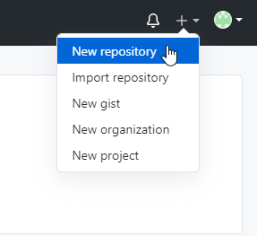
1.3 Enter sample repository in the Repository field. Entering a Description is optional.
1.4 Choose Public for the repository type.
1.5 Select Initialize this repository with a README to include a README file for the repository.
1.6 Click on the Create Repository button.
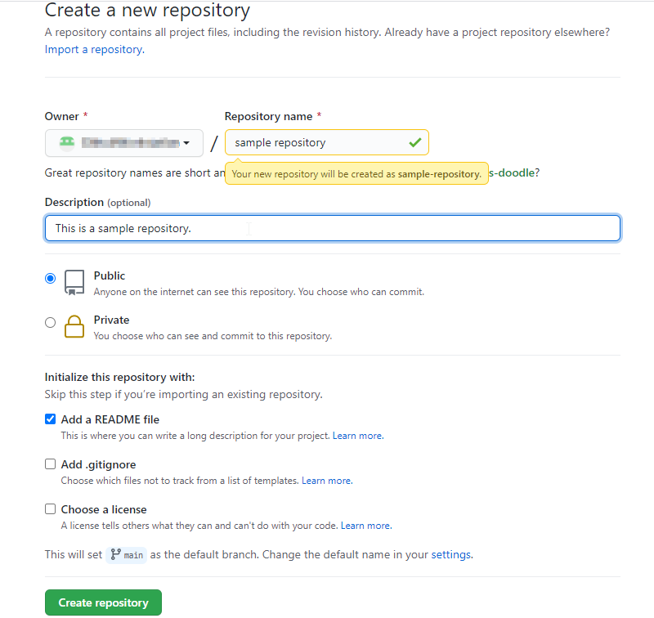

Step 2: Edit the README file
2.1 Click on the Edit button to edit the README file.
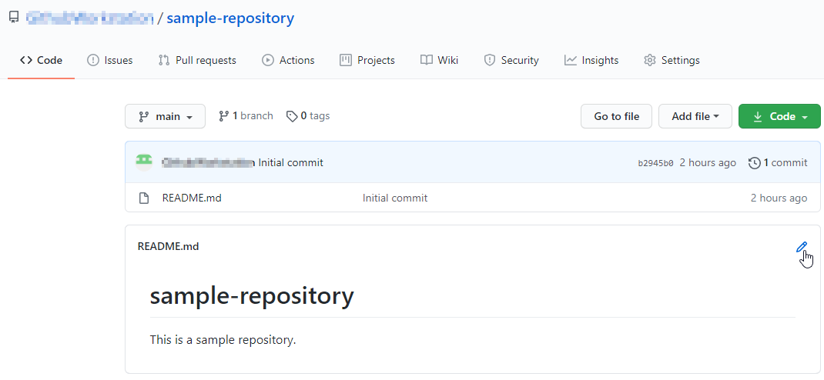
2.2 Add some text in the README file (Example: We have edited the README file.)
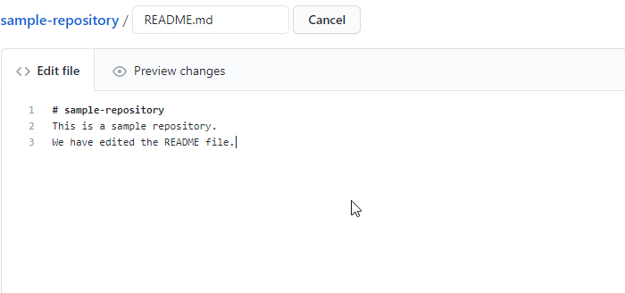
2.3 Type a commit message to describe the changes made in the file and then click on Commit changes
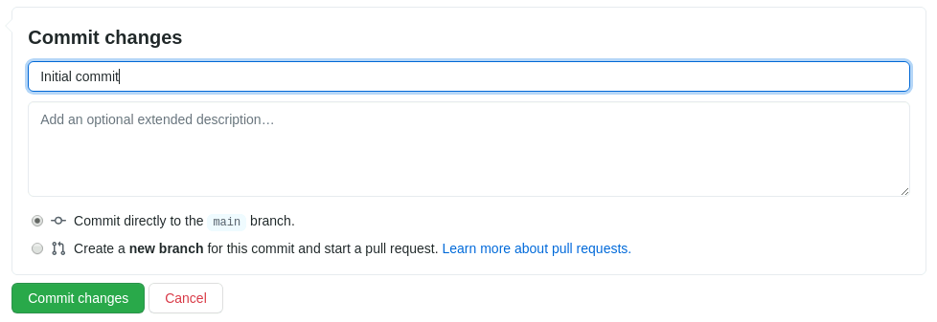

Step 3: Upload a file to the repository
3.1 Go to your Github repository and to add a file to the repository, click on Add file, and then select Create new file
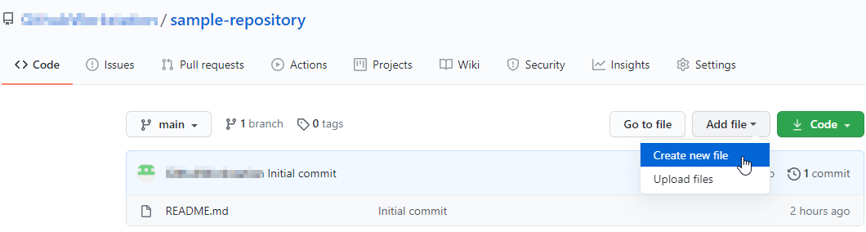
3.2 Enter the filename as SampleFile.txt, and add the following text in the Edit new file tab.
This is a sample file.
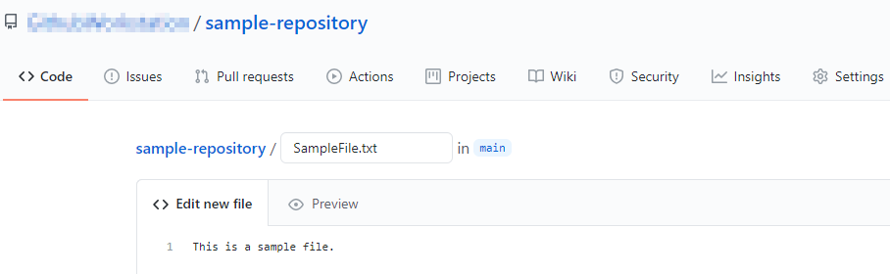
3.3 Next, scroll down to the Commit New File section. Write a Commit Message (Example: Create SampleFile.txt) and click on the Commit New File button
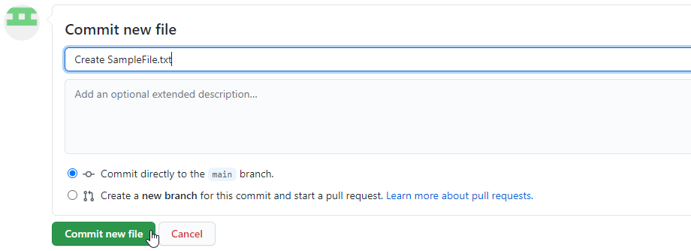
3.4 Check the newly added file with the commit message
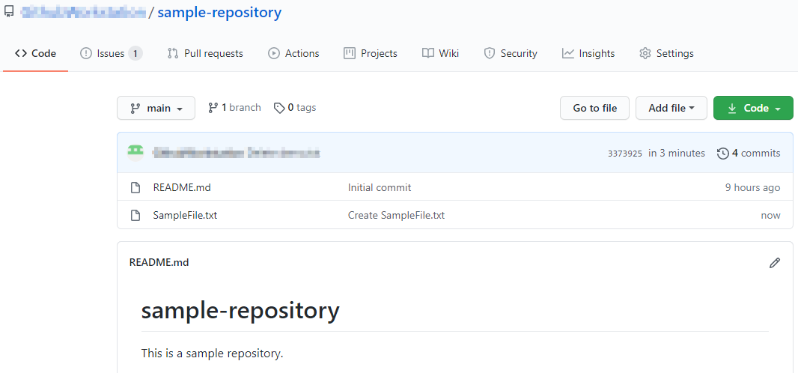

Step 4: Clone a GitHub repository
4.1 Open the browser in your lab, go to github.com, and login to your account
4.2 Open the sample-repository repo, and click on the Code button.
4.3 Click on the icon as shown in the following image to copy the url provided under HTTPS.
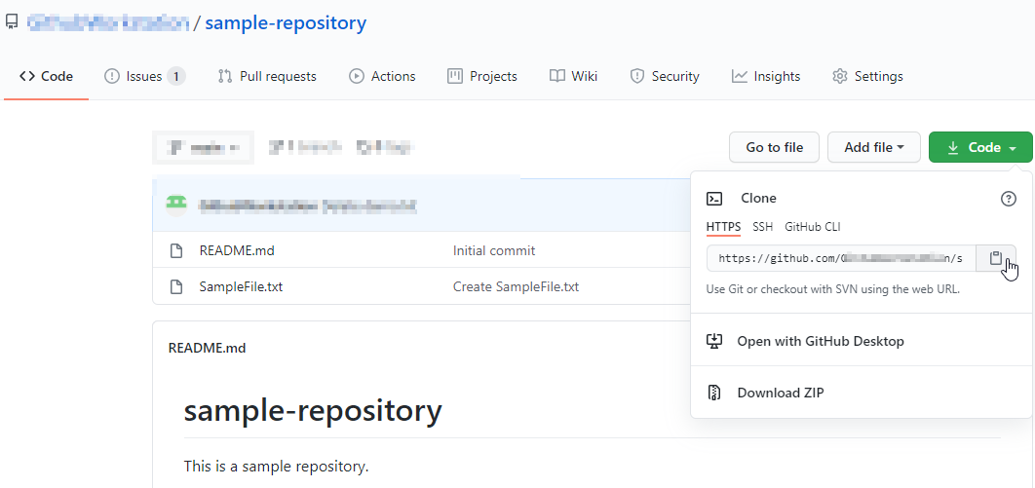
4.4 Open the Terminal tab on your lab, and use the following command to clone the repository:
git clone URL
Note: Replace the URL with the copied URL from the repository.

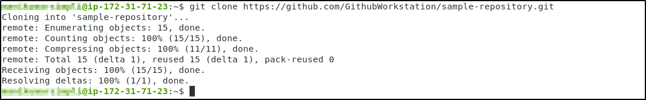
4.5 Use the following command to check the cloned repository:
ls

4.6 Navigate to the sample-repository, and check the files inside the repository.
cd sample-repository
ls


